**Experiment No.: 6 Date: 14-03-2023**

**AIM**: Familiarization of linux commands.

**CO2**: Perform system administration task.

**Procedure:**

1.grep -i : to search something(case sensitive searching)

$grep -i filename

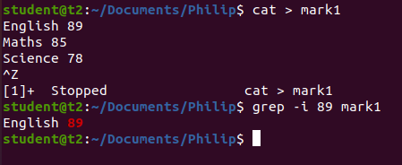

1.1.grep -v: This prints out all the lines that do not matches the pattern

$grep -v filename

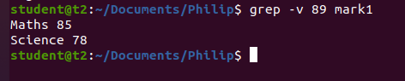

1.2 Grep -A1: Prints searched line and nlines after the result.

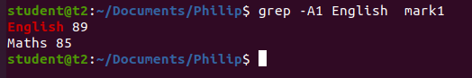

1.3Grep -B1: Prints searched line and n line before the result.

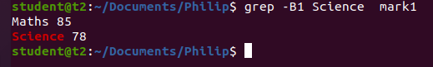

1.4 Grep -C1 : Prints searched line and n lines after before the result.

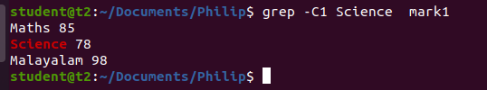

1.5 head - Display first 10 lines of a file

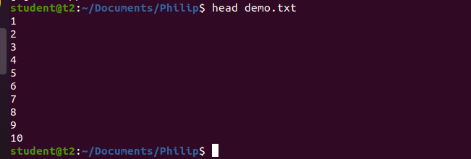

1.6Head -n :Display first n lines of a file

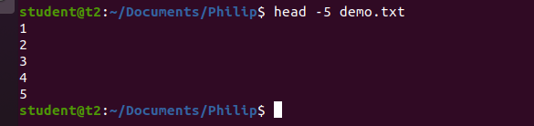

1.7 Tail : Display last 10 lines of a file

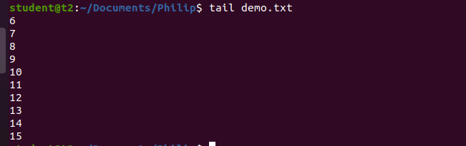

1.8 Tail -n : Display last n lines of a file

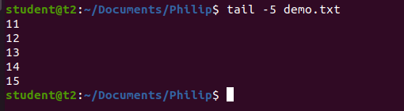

2. Mv : used to move one file from one location to other and content will be over written

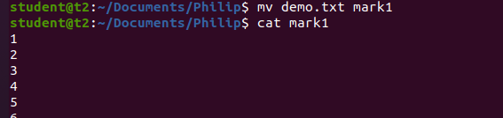

2.1 mv -b : backup a file

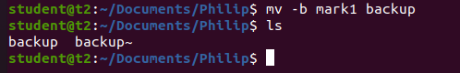

2.2 mv -i : Display warning of over writing

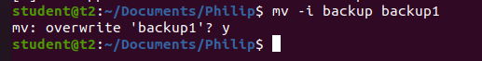

**Result**

The program was executed and the result was successfully obtained. Thus CO2 was attained